Practical No: 00

**Aim**: Starting Raspbian OS, Familiarizing with Raspberry Pi Components and interface, connecting to Ethernet, Monitor, USB.

**Hardware Required:**

1. Raspberry Pi 3B+
2. Ethernet Cable
3. Monitor
4. HDMI to VGA convertor
5. Micro SD card (any class best is class 10)
6. Adaptor with 5v 2A
7. USB mouse
8. USB keyboard

**Software Required:**

1. Raspbian OS (<https://www.raspberrypi.org/downloads/raspbian/>)
2. Etcher for Windows (<https://www.balena.io/etcher/>)

**Procedure:**

1. **Installing Raspbian**

* Download Raspbian OS (will be in zip format).
* Unzip it
* Download the windows installer of Etcher.
* Run Etcher.

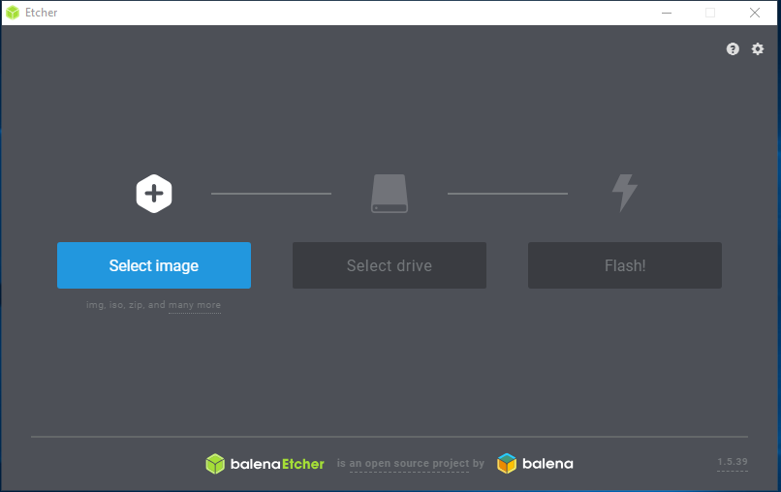

* Select the SD card drive.

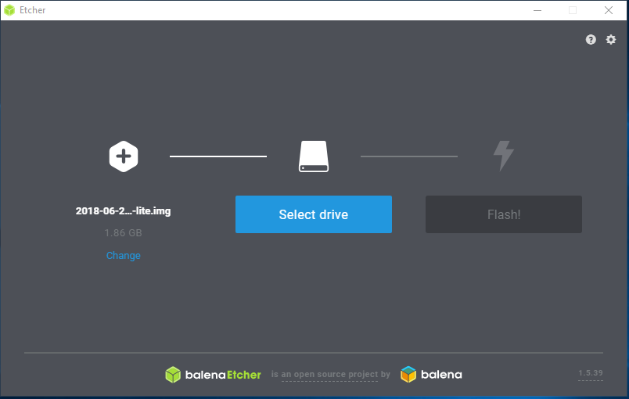

* Finally, click “Flash” to write the Raspbian image to the SD card.

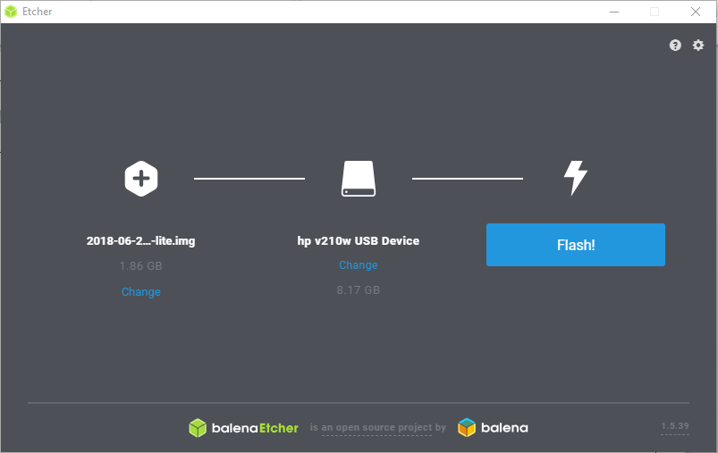

* You’ll see a progress bar. Once complete, the utility will automatically

Unmounts the SD card so it is safe to remove it from your computer.

1. **Connecting Components**

* Insert the prepared SD card in the SD card slot in the Raspberry Pi. 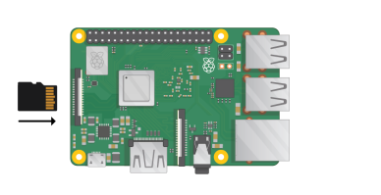
* Connect USB mouse and Keyboard

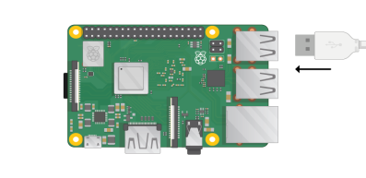

* Connect the HDMI to convertor with the VGI cable with the monitor.

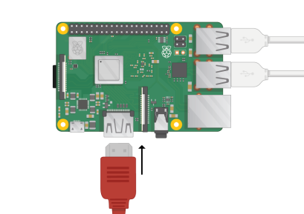

* Connect Ethernet to Router or Switch

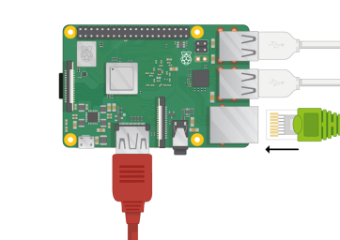

* Switch on the monitor
* Provide Power to the Raspberry Pi by connecting Adapter.

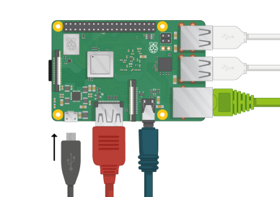

**Precautions:**

1. While connecting components follow the above steps as it is, remembering that power should be provided at the end.
2. Remember to un-mount the SD card before removing it from PC as this may lead to data corruption.

**Conclusion:**

1. We have learned the basic steps to get started with Raspberry Pi.

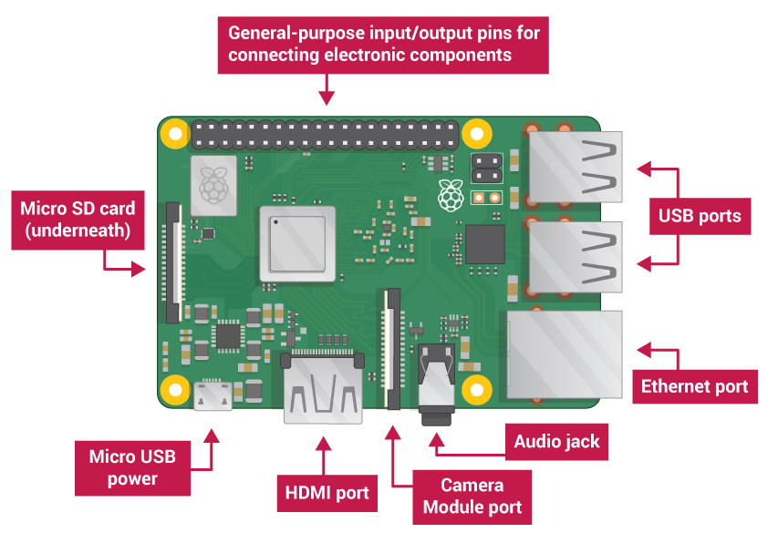

* **USB ports**: these are used to connect a mouse and keyboard. You can also connect other components, such as a USB drive.
* **SD card slot**: you can slot the SD card in here. This is where the operating system software and your files are stored.
* **Ethernet port**: this is used to connect the Raspberry Pi to a network with a cable. The Raspberry Pi can also connect to a network via wireless LAN.
* **Audio jack**: you can connect headphones or speakers here.
* **HDMI port**: this is where you connect the monitor (or projector) that you are using to display the output from the Raspberry Pi. If your monitor has speakers, you can also use them to hear sound.
* **Micro USB power connector**: this is where you connect a power supply. You should always do this last, after you have connected all your other components.
* **GPIO ports**: these allow you to connect electronic components such as LEDs and buttons to the Raspberry Pi.